**PROJECT:** “REDUCING ENERGY CRISES IN PAKISTAN USING MACHINE LEARNING”

BY

OMDENA PAKISTAN CHAPTER | [OPC](https://omdena.com/omdena-chapter-page-pakistan/)

SUPERVISOR

NGUYEN DIEU HOA | [NGUYEN.GMAIL](mailto:NGUYENDIEUHOA15@GMAIL.COM)

OMDENA PAKISTAN CHAPTRER

**Abstract**

Pakistan is one of the populous countries in Asia and has been facing electricity, despite being rich in resources. Reasons for this are often attributed to poor policy decisions and inadequate utilization of resources. In this project I estimate access to electricity and the solar energy budget of Pakistan, as to propose a solar photovoltaic energy expansion plan. The results of these are combined to find areas of Pakistan, where allocation of electricity generation resources ensures the most people get access to electricity for the lowest capital investment. The project can be reproduced in other developing countries and aims to aid policy decision makers and funders make the best choices. All code is available at: <https://github.com/OmdenaAI/omdena-pakistan-energy-crisis> [project](https://github.itu.dk/shro/bachelor_project).

# Contents

### Introduction ……………….……………………………………………………. 2

1. **Electricity deficit: Estimating access to electricity ……………………………2**
   1. Data sources and preprocessing 3
      1. Access to electricity 3

* + 1. Powerplants Dataset 5
    2. Load Shedding Survey 6

1. Solar Radiations Density: Estimating solar density …………………………6
   1. Global Solar Atlas 6
   2. Usageof Atlas Dataset7
2. Implementation: Project Dashboard………………………………………….7
   1. Visualizing the Pakistan 7
   2. Suggested areas and settlements 8
   3. Energy demand and potential solar energy 8
3. Conclusive remarks ………………………………………………………….10
   1. Future work 10

**References……………………………………………………………11**

1. **Introduction**

Pakistan has a population of 224m people yet only 3/4 have access to 24/7 electricity. Without electricity, there are no computers or the internet. There are no fridges to keep food fresh. There is no electric water pump. There is nowhere to charge a mobile phone.

Schools and Hospitals struggle to provide basic services. Widening electricity access is an essential first step for improving education, healthcare, and local economies. The government has built-in failure by fixing prices and profits; there is widespread corruption, and banks will not lend to new power plants. Meanwhile, half the existing plants lie idle, and the rest operate below capacity. Millions live under the grid but not connected to it; previously connected but some equipment failed and has not been replaced, or they have electricity but only enough for a light bulb; or they have it, but it is unreliable due to daily power cuts. This initiative’s goal is to use Pakistan census data in conjunction with other relevant datasets to identify sites that are most suitable for solar panel installation through data analysis.

# 2 Electricity deficit: Estimating access to electricity

The project’s goal is to use Pakistan's Availability of electricity dataset to identify sites that are most suitable for solar panel installation as a greener energy source through data analysis. We used the load shedding survey combined with load shedding hours from different news articles and power plant dataset, we estimated the access to the electrical energy of different division of Pakistan.

After analyzing the access to electricity and solar radiations per square meter of area (division). Then proposed the settlements for the divisions.

## Data sources and preprocessing

### Access to electricity

The census organization was set up in 1950 as a portion and allocate of Service of Domestic Issues and to begin with three censuses were conducted by this organization whereas working beneath that Service. After 1972 Census, Census Organization was set up on a changeless balance and was made a joined division of Service of Insides, so as to preserve mastery, encounter and progression which utilized to be misplaced after each census as was the case in 1951 and 1961. With the creation of Enrollment organization in 1973, as a joined division of Ministry of Insides additionally headed by Census Commissioner, both the offices were blended in 1976 to be called “Census & Enrollment Organization”. In Walk 1978, the “Census & Enlistment Organization” was part into two isolated offices and Populace Census Organization was set beneath the Insights Division which remains as such from that point due to proclamation of Common Measurements (Re-organization) Act, 2011. The conduct of Census is the responsibility of Pakistan Bureau of Statistics. It is knowledgeable that CCI determined on sixteenth December 2016 to behavior the Population and Housing Census-2017 in two levels with the guide of Armed Forces. In order to conduct Population & Housing Census in the country, Pakistan Bureau of Statistics (PBS) demarcated the whole country into small compact area called Census Blocks comprising of 200-250 houses on an average, with total number of 1,68,943 blocks with well-defined boundaries and maps. It is really well worth bringing up right here that the entire delimitation system turned into done with the near coordination of Provincial Governments, Local Government, Revenue Department and District Administration. Further Provincial Coordination Committees headed via way of means of involved Chief Secretaries and Secretaries of applicable departments i.e. Education, Revenue, Local Government as a Members had been notified for behavior of transparent, credible census and for whole insurance. Similarly, Divisional, District and Census District (Tehsil / Taluka) Coordination and Vigilance Committees had been notified for whole insurance of areas, tracking of records first-class and subject paintings of Census-2017. Appointment of Field Staff (Enumerators, Circle Supervisors, Charge Superintendents) turned into made via way of means of the District Management from the Provincial Education, Revenue, Population Welfare and different associated Departments.

Census-2017 turned into performed in levels. Each segment had length of 30 days. Phase-I commenced from fifteenth March and ended on 14th April 2017 wherein sixty one Admin Districts comprising of 79,773 blocks had been enumerated. Phase-II commenced with an opening of 10 days from twenty fifth April until twenty fourth May, 2017. Eighty-Nine (89) Admin Districts comprising of 89,170 blocks had been enumerated for the duration of this period. The subject operation consisted of first three days for residence list accompanied via way of means of 10 days for populace rely and at some point for enumeration of homeless populace. De-Jure approach (typical location for residence) used for records series as consistent with exercise followed withinside the beyond censuses. In order to lend credibility to the Census operation, the sample of 1998-Census turned into followed, with a solider accompanying every enumerator. One group turned into assigned blocks withinside the identical vicinity. The general civilian subject and tracking Staff deputed via way of means of provincial governments turned into 108000. The Armed Forces furnished 200,000 Army Personnel for Census duty, of which, 44,000 had been deployed with civilian enumerators. The final employees had been used for protection duty, command shape and logistic guide.

For a hit behavior of Census, development in census strategies and involvement of stakeholders, Government of Pakistan constituted a Sub-Committee of the Governing Council of PBS which includes famed Demographers and Experts on thirty first January 2017 with phrases of reference to supervise the entire census system from trainings, records series, processing and finalization of consequences. Similarly, provinces on request of Federal Government constituted Provincial Technical Committees to monitor the records processing and finalization of consequences system. Further, group of International (5) / National (12) visited all provinces and Gilgit Baltistan to examine the first-class of the Census and adoption of the global standards. Further, Control Rooms had been hooked up in Provincial Level and PBS Headquarters for redressal of the court cases gets for the duration of Census operation.

Keeping in view the sensitivity of the Census consequences the Cabinet determined to represent a Ministers Committee on 11.02.2020 for specific deliberations on the problem with stakeholders and for pointers concerning finalization of consequences of Census-2017. The Committee performed six conferences and after good sized discussions & concerns submitted its record with pointers for approval of consequences of Census-2017 in a bigger country wide hobby and to the behavior subsequent census in advance feasible via way of means of adopting current technologies. The Cabinet in its assembly hung on 22.12.2020 authorized the Committee pointers for forwarding it to CCI for very last attention being the in a position forum. The CCI in its assembly hung on 12.04.2021 deliberated at the problem and authorized the very last consequences of Census-2017. According to the very last consequences of Census-2017 the populace of Pakistan is 207.68 million (with -0.043% distinction with provisional consequences) with populace increase charge of 2.40% from 1998 to 2017 with 106.three million men and 101.three million females.3

### Powerplants Dataset

Pakistan has a total installed power generation capacity of over 40,000 MW as of 5 April 2021. Furnace oil (15 percent), hydel (26 percent), natural gas (12 percent), LNG (25 percent), coal (9 percent), renewable (solar and wind 5 percent) and nuclear (8 per cent) are the principal sources.

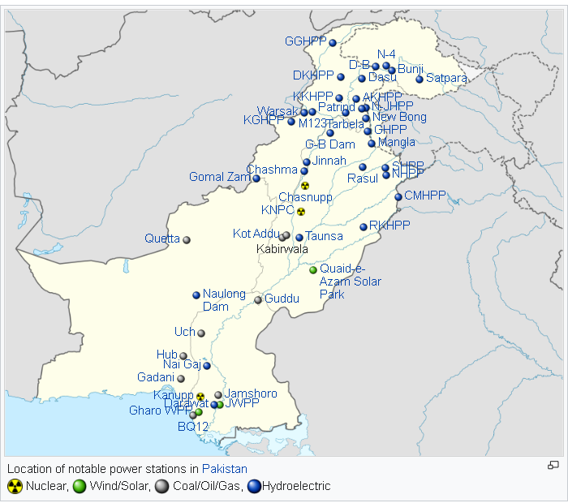

Figure source: wikipedia

3PBS websitehttps://www.pbs.gov.pk/

### Load Shedding Survey

### We surveyed the load shedding intensity in different cities and divisions of Pakistan. We got almost

### 200 responses from the different areas of Pakistan showing the load shedding intensity.

### 

### We utilized this dataset to determine the access of electricity in different areas of Pakistan.

# Solar Radiations Density: Estimating solar density

## Global Solar atlas

## The World Bank and the International Finance Corporation, collectively The World Bank Group,

## have provided this Global Solar Atlas in addition to a series of global, regional and country GIS

## data layers and poster maps, to support the scale-up of solar power in our client countries. This

## work is funded by the Energy Sector Management Assistance Program (ESMAP), a multi-donor

## trust fund administered by The World Bank and supported by 13 official bilateral donors. It is part

## of a global ESMAP initiative on Renewable Energy Resource Mapping that includes biomass, small

## hydro, solar and wind.

## The objective of the Global Solar Atlas is to provide reliable introductory-level data to help

## Policy makers, researchers, and commercial solar companies take better decisions. For project-

## specific analysis of large power plants, the data available via the Global Solar Atlas is suitable only

## for preliminary analysis. The PV yield estimates do not account for many important factors that can

## impact potential yield of a photovoltaic power plant. For large power plants, it is recommended to

## work with more detailed yield estimation tools in order to obtain a precise estimate of energy yield.

## Usage of Atlas dataset

We utilized photovoltaic PVOUT and Direct normal irradiation to determined top places where solar radiations in Pakistan is large and display them in as suggested settlements in combinations with households and population density.

# Implementation: Project dashboard

## Visualizing the Pakistan

## 

Our Web App has 4 modes that emphasize distinctive data. Dull mode highlights the Proposed Areas/Settlements best suited for sun-based board establishment. Light mode appears the same data, but custom fitted for those with color visual impairment. Road mode shows the most thruways for transport whereas adj. gives the real outline of the proposed ranges/ settlements. Below the Map Mode Menu, you'll be able see the regions positioned by their require for sun-oriented vitality. These are moreover highlighted within the outline by Dabs (see 'Marker Labels' legend). You will rummage around for a division utilizing the View bar.

## Suggested Areas & Settlements

## 

## Our suggested places and settlements are marked in Green Dots for Area and Blue Dots for more granular Settlement’s data. Clicking on the Green Dot, more information about the area will be shown in the sidebar. These settlements are identified by a calculated site suitability score according to multiple datapoints for that area (i.e. low night light, access to electricity, and installed electric capacity).

## Energy Demand and Potential Solar Energy

As you explore more municipalities in the Pakistan that would greatly benefit from solar energy, we matched the demand data with an estimated output of solar energy that will be produced for that area.

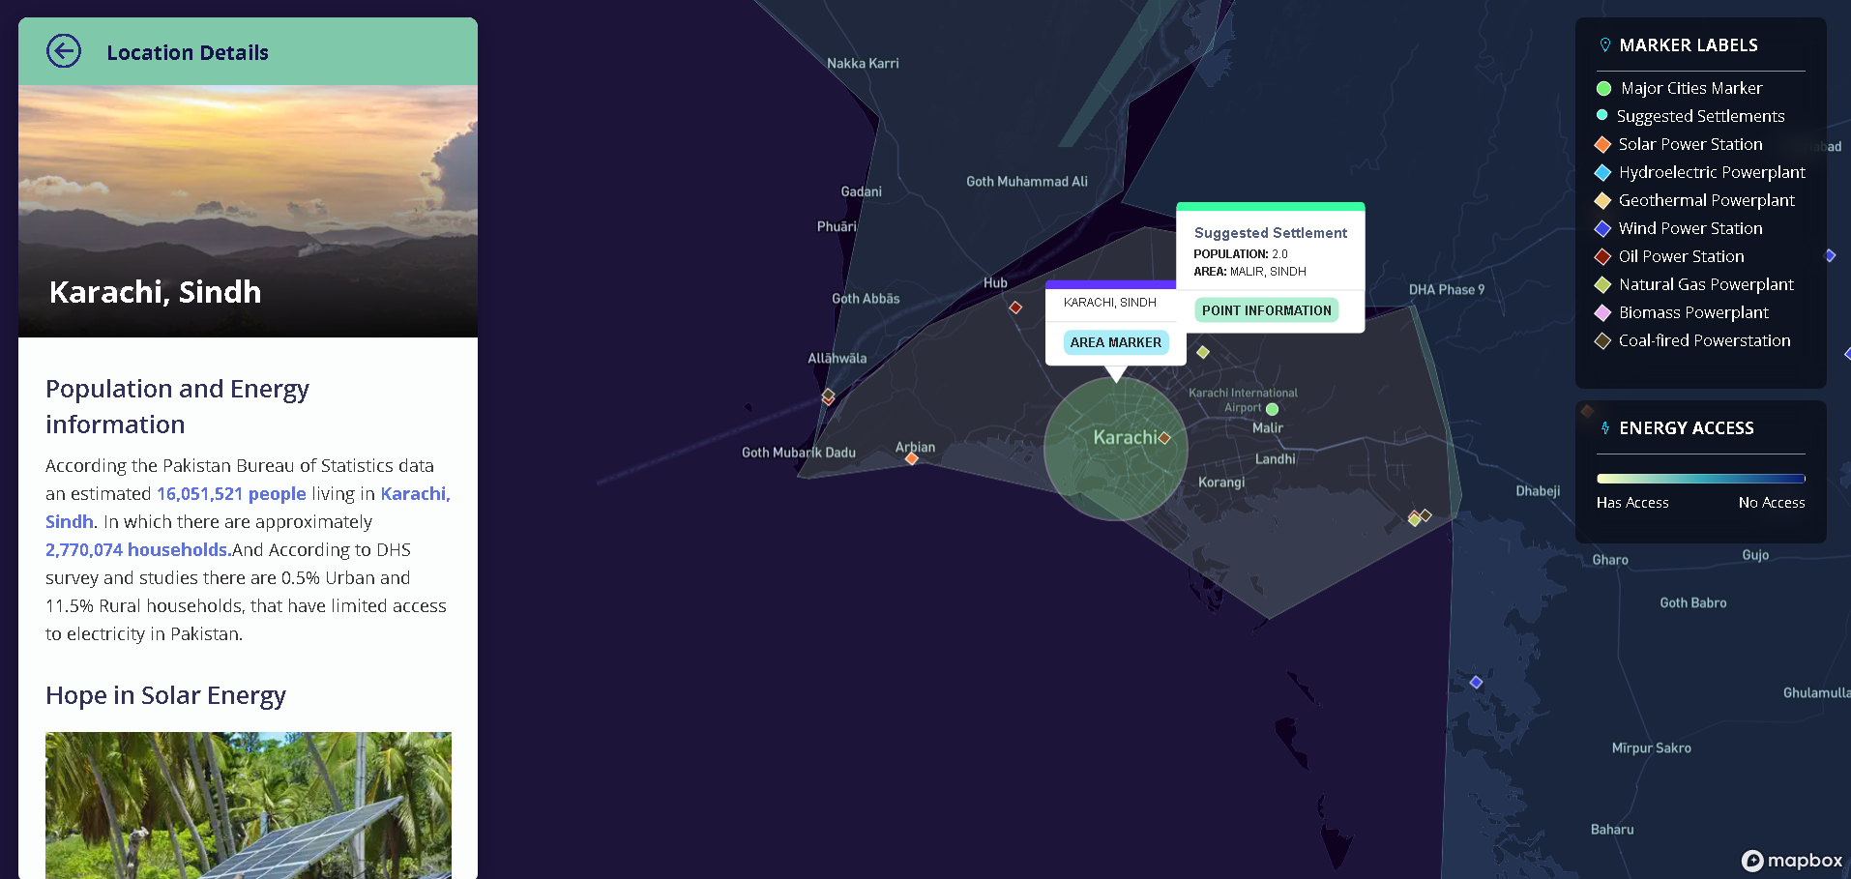

Using the Solar Global Atlas, we estimate the mean PVOut that installing solar panels could produce for that Area/Municipality. Granular settlements (in Blue Dots) are also marked for installing solar micro grids all over the municipalities.

# Conclusive remarks

In this project, a study based on the current energy situation of Pakistan has been put forward. The project aims at analyzing the current energy capacity of the country and also the access to electricity by different areas across the country. Based on the energy availability, the regions of the country are divided into further parts contributing to amount of electricity access. Access to electricity was mapped using the survey data for energy accessibility and contours are drawn pertaining to a region with a specific type of abundance of electricity availability. Moreover, locations across the country are also proposed for the eligibility of a potential solar power site for its contribution in the energy production of the country.

The proposed methodology can not only aid Pakistan, but also other developing countries stricken by energy shortage in the country for better future prospects of both the country and its people using renewable environment friendly production.

## Future work

Regarding the future expansion of the current project, we can use multiple other data sources not available at the moment for the country. We could use night light data to perform segmentation pertaining to the energy availability, combined with the survey data and government achieved data to build a clustering algorithm which can automatically detect energy deprived areas using the given data. However, this would also require substantial code optimization or larger computational power. A proper method of validation, incremental improvements could be introduced to the model as well.

# References

https://www.pbs.gov.pk/sites/default/files//DISTRICT_WISE_CENSUS_RESULTS_CENSUS_2017.pdfAkpabio, Louis and Sunday Etuk. 2003. Relationship between global solar radiation and sunshine duration for onne, nigeria. *Turkish Journal of Physics*, 27:161–167.

https://pndajk.gov.pk/uploadfiles/downloads/AJK%20At%20A%20Glance-2020.pdf.

https://globalsolaratlas.info/map?c=11.523088,8.349609,3.

http://www.gilanifoundation.com/average-load-shedding-time-pakistanis-continue-to-face-6-hours-of-load-shedding-per-day-urban-pakistanis-experience-two-hours-less-load-shedding-as-compared-to-an-average-pakistani/

<https://en.wikipedia.org/wiki/List_of_power_stations_in_Pakistan>

<https://en.wikipedia.org/wiki/List_of_hydroelectric_power_stations_in_Pakistan>

<https://geohack.toolforge.org/>